CS 255 System Design Document Template

UML Diagrams

UML Use Case Diagram
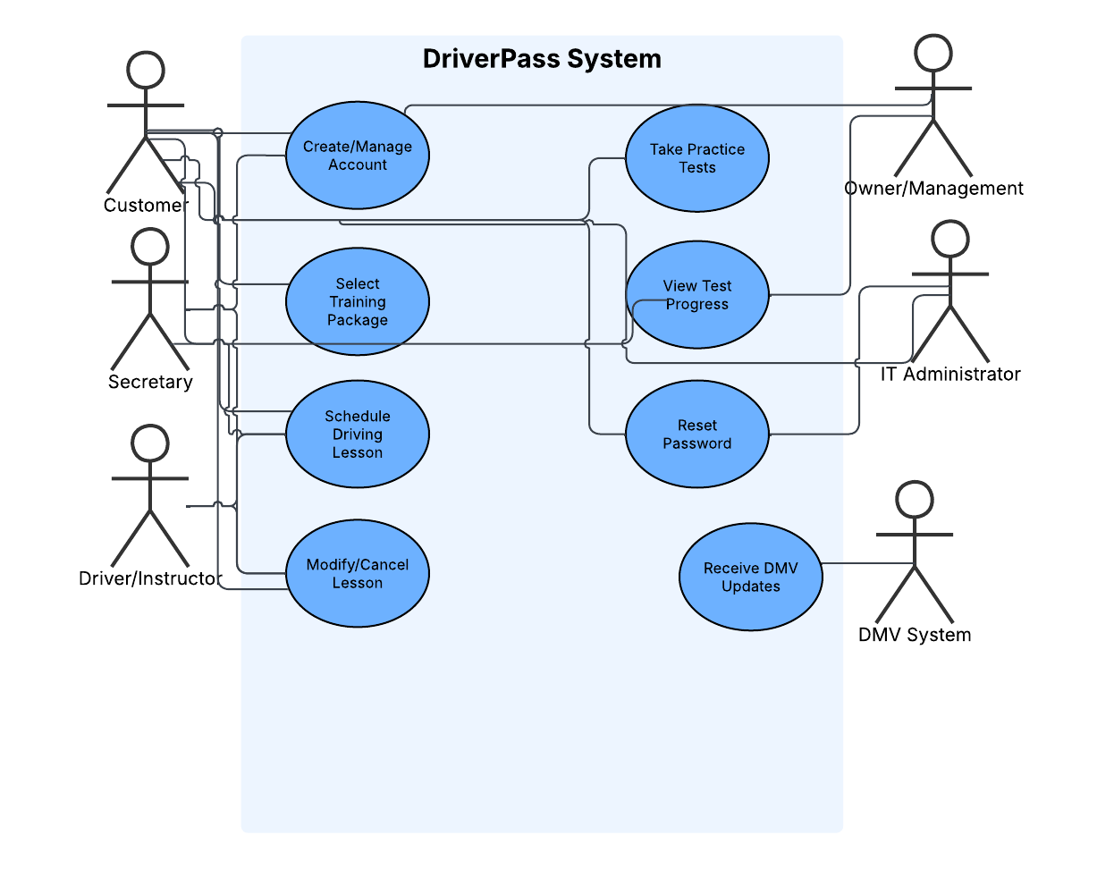

UML Activity Diagrams

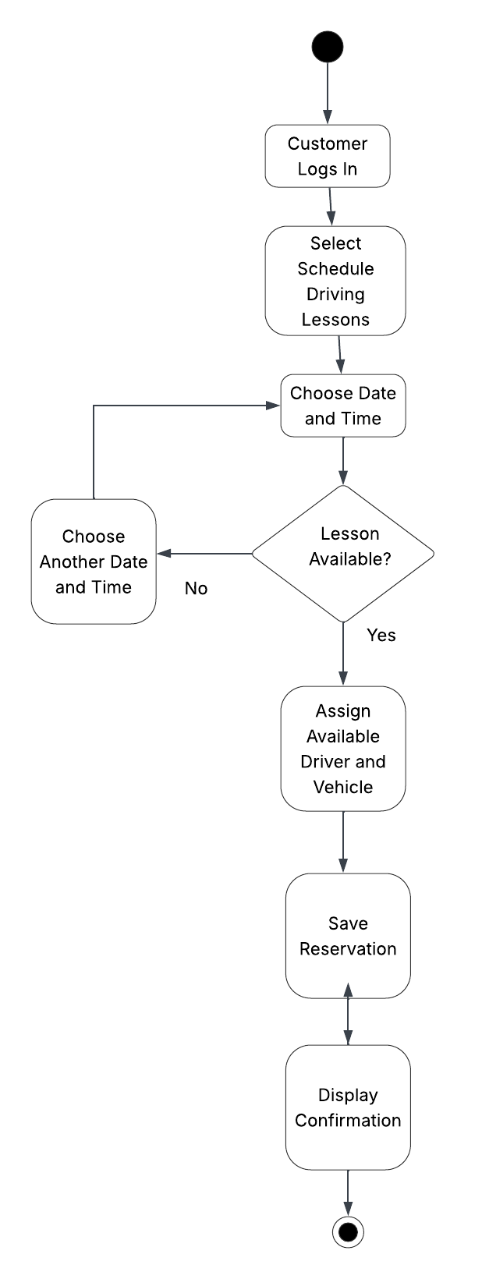

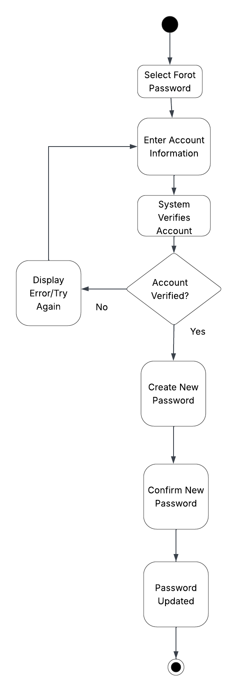

UML Sequence Diagram
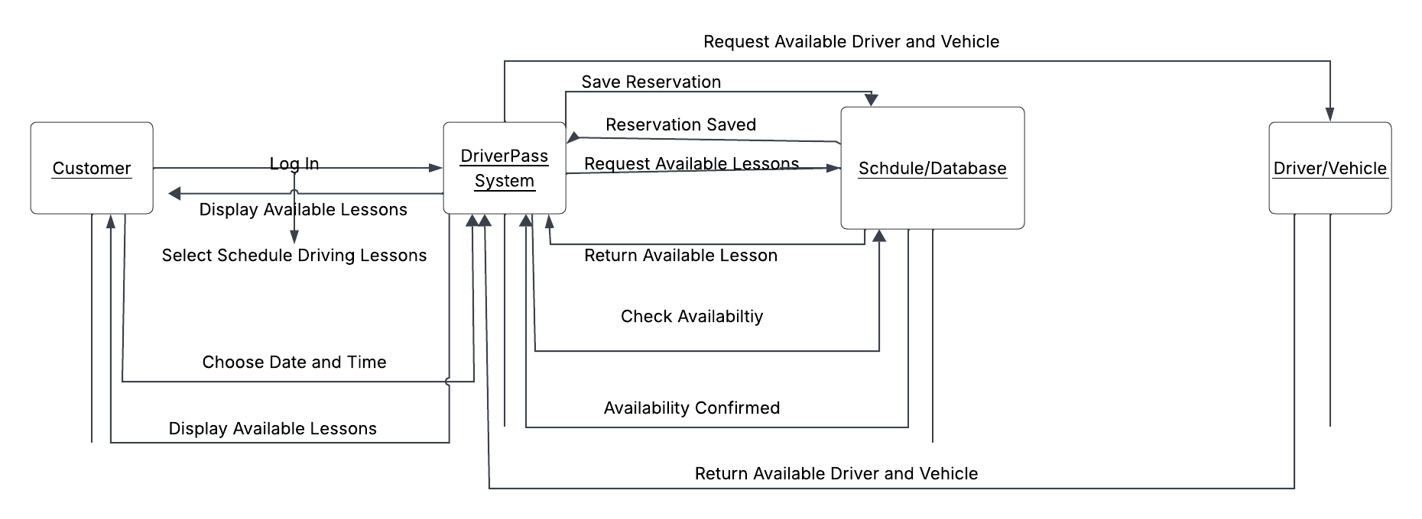

UML Class Diagram

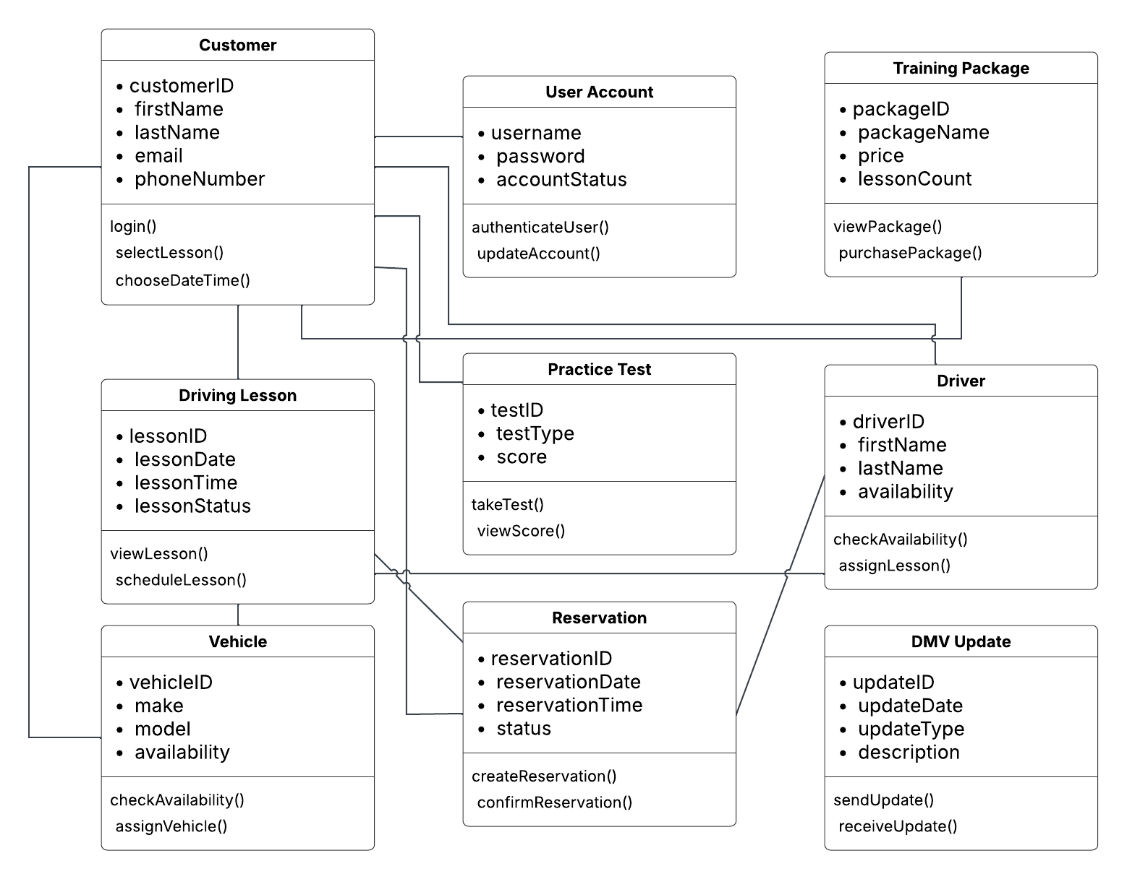

Technical Requirements
The DriverPass system will require reliable hardware and internet access to support customers and employees. DriverPass employees will need computers or other compatible devices with internet access to manage customer accounts, reservations, training packages, and reports. Customers will need an internet-connected computer, tablet, or mobile device to access the system. The system will also require server infrastructure capable of storing customer information, reservations, practice test results, driver schedules, vehicle information, and other business data.

The software should be web-based so users can access DriverPass through common web browsers without installing additional software. A database management system will be needed to securely store and retrieve system information. The system should also support connections to DMV information so that updated rules, policies, and practice questions can be incorporated when needed. Security measures should include user authentication, role-based access, secure password management, data encryption, and regular backups. The infrastructure should be scalable so DriverPass can support additional users and system updates as the business grows.

